**Graph 1:**

ggplot(data = survey_results_public, aes(x = Professional, fill = FormalEducation)) + geom_histogram(stat = "count", col = "black", alpha = 0.7, position = "dodge") + labs(title="Professionalism in Stack Overflow", subtitle = "An anaylsis of formal education versus profession amongst Stack Overflow Users", caption = "(Based on data from the 2017 Stack Overflow User Survey) - Jerry Cheng") + labs(x = "Profession", y = "User Count") + theme(legend.background = element_rect(fill = "white", size = 0.5, linetype = "solid", color = "black")) + theme(legend.position = c(.85, .8)) + theme(axis.line = element_line(size = 3, color = "grey80"))

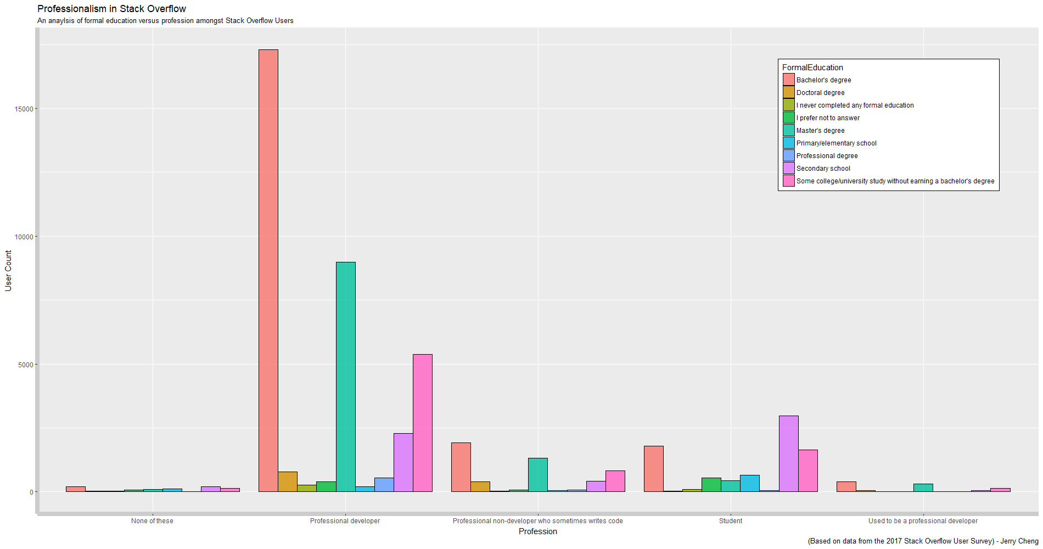

**Graph 2:**

**1:** ggplot(data = survey_results_public, aes(x = Gender, fill = Gender)) + geom_bar(col = "black", alpha = 0.7) + theme(axis.text.x=element_text(size = 10, angle = 45, hjust = 1, vjust = 1)) + scale_y_continuous(trans = 'log2') + labs(title="Genders/Sexualities Amongst Stack Overflow Users", subtitle = "A graph detailing genders or sexualities in the Stack Overflow community", caption = '(Based on data from the 2017 Stack Overflow User Survey) - Jerry Cheng') + theme(axis.line = element_line(size = 3, color = "grey80")) + theme(legend.position = "none")

**2:** ggplot(data = survey_results_public, aes(x = Gender, fill = Gender)) + geom_bar(col = "black", alpha = 0.7) + theme(axis.text.x=element_text(size = 10, angle = 45, hjust = 1, vjust = 1)) + labs(title="Genders/Sexualities Amongst Stack Overflow Users", subtitle = "A graph detailing genders or sexualities in the Stack Overflow community", caption = '(Based on data from the 2017 Stack Overflow User Survey) - Jerry Cheng') + theme(axis.line = element_line(size = 3, color = "grey80")) + theme(legend.position = "none")

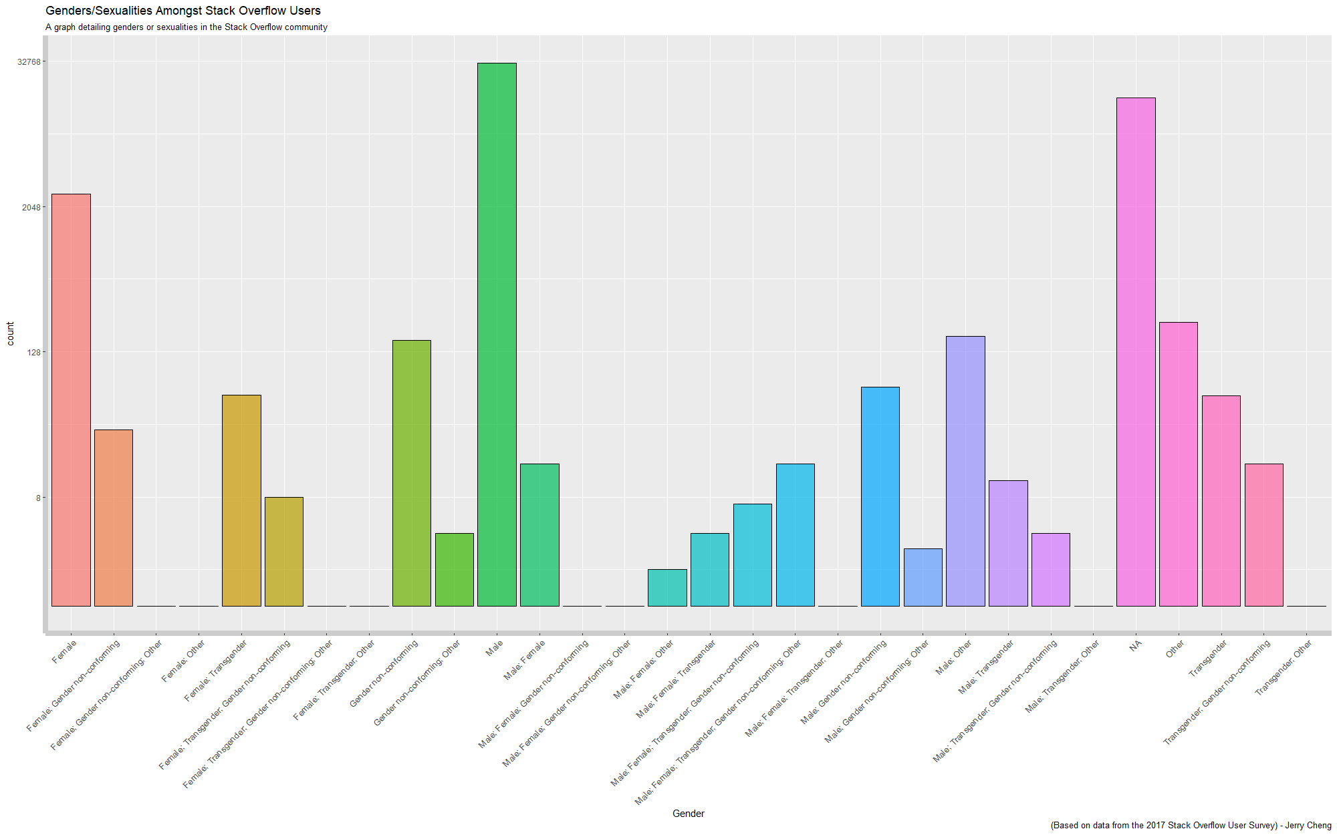

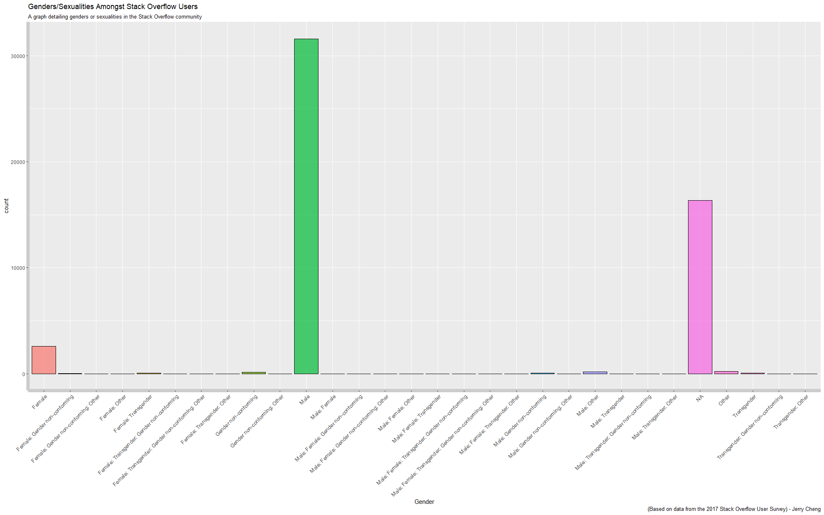

**Graph 3:**

ggplot(data = survey_results_public, aes(x=PronounceGIF, fill = Professional)) + geom_bar(col = "black", alpha = 0.7) + labs(title="Jiff, Gif, or G - I - F?", subtitle = "The controversial question, answered by Stack Overflow users", caption = "(Based on data from the 2017 Stack Overflow User Survey - Jerry Cheng)") + theme(legend.position = c(.2, .8)) + theme(legend.background = element_rect(fill = "white", size = 0.5, linetype = "solid", color = "black")) + + theme(axis.line = element_line(size = 3, color = "grey80"))

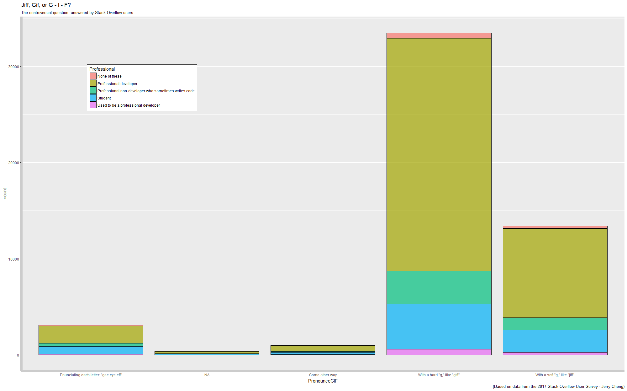

**Graph 4:**

ggplot(data = survey_results_public, aes(x=TabsSpaces, fill = TabsSpaces)) + geom_bar(col = "black", alpha = 0.7) + theme(legend.position = "none") + labs(title="Tabs or Spaces?", subtitle="Do Stack Overflow Users use tabs or spaces?", caption = "(Based on data from the 2017 Stack Overflow User survey) - Jerry Cheng") + labs(x = "Tabs or Spaces?", y = "User Count") + theme(axis.line = element_line(size = 3, color = "grey80"))

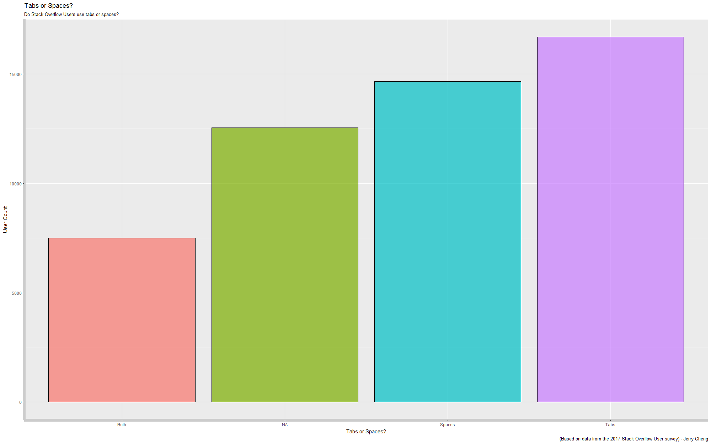

**Graph 5:**

ggplot(data = survey_results_public, aes(x = CompanySize, fill = HomeRemote)) + geom_bar(col = "black") + theme(legend.position = c(.7, .8)) + theme(legend.background = element_rect(size = 0.5, linetype = "solid", color = "black")) + labs(title = "Company Size vs. Working From Home", subtitle = "Stack Overflow users' companies and their opportunities to work from home", caption = "(Based on data from the 2017 Stack Overflow User Survey) - Jerry Cheng") + labs(x = "Company Size", y = "User Count") + theme(axis.line = element_line(size = 3, color = "grey80"))

